# **FlipShop – Use Cases**

**Table of Contents**

FlipShop – Use Cases 1

List of Figures 1

Use Case # 1 – Ideal Case 1

Description 1

Sequence Diagram 2

Description 3

Sequence Diagram 3

Use Case # 3 – Block User by Admin 4

Description 4

Sequence Diagram 4

Use Case # 4 – Price Prediction Blog 5

Description 5

Flow Chart Diagram 5

Use Case # 5 – Price Prediction Daraz 5

Description 5

Flow Chart Diagram 5

Use Case # 6 – Logical Implementation 6

Description 6

Flow Chart Diagram 6

Use Case # 7 – Cron Jobs 7

Description 7

Flow Chart Diagram 7

## **List of Figures**

Figure 1- Ideal Case 2

Figure 2- Disputed Case 3

Figure 3- Block User 4

Figure 4 - Price Prediction - Blog 5

Figure 5 - Price Prediction - Daraz 5

Figure 6- Data Response 6

Figure 7- Logical Implementation 6

Figure 8- Cron Jobs 7

## **Use Case # 1 – Ideal Case**

### **Description**

This scenario lists the successful selling/buying of the asset with the “fixed” pricing model. The seller lists the asset on the platform while the buyer will make offer on the listed asset. Once the offer is accepted by the seller, the seller must make and send a contract to the buyer by specifying an opening and closing date. Once the contract is sent, the buyer is liable to make payment within the contract period. In this scenario, the buyer makes the payment to the system. Once the seller receives the notification, that system has received the payment, only then seller can send credentials to the buyer. Once the seller sends the credentials and the buyer approves them, the payment will be released from the system to the seller.

### **Sequence Diagram**

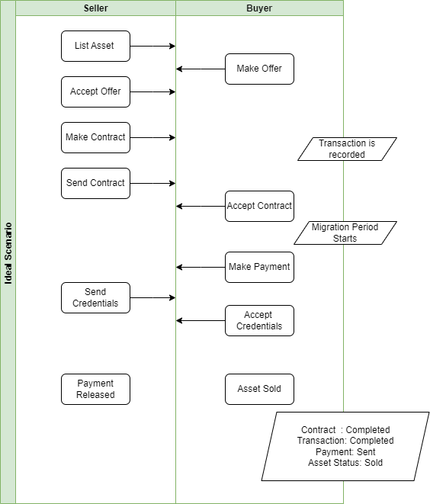

Figure 1- Ideal Case

**Use Case # 2 – Disputed Case**

### **Description**

This scenario lists the disputed version for the selling process. All the steps from Use Case # 1 will be repeated until the buyer, instead of approving the credentials, will reject them. This will automatically open a dispute among both parties. Both parties will be allowed to select any of the two options as presented in the following diagram: “Pay Seller” or “Pay Buyer”. If both parties select the same option, the dispute will be resolved. If both parties select “Pay Buyer”, it means the contract will be aborted and transaction will be cancelled with the payment reverted to buyer. If both parties select “Pay Seller”, it means the contract and transaction will be completed with payment released from system to seller. However, in the case where neither party does not reach any mutual consensus or within one week, any of the parties do not select any of the provided options, the admin will get authorized to intervene in the dispute. The admin can then select any of the same options to resolve the dispute.

### **Sequence Diagram**

Figure - Disputed Case

## **Use Case # 3 – Block User by Admin**

### **Description**

This scenario displays the authority of admin to block any of the user. However, if the user has any ongoing transaction, the user cannot be blocked.

### **Sequence Diagram**

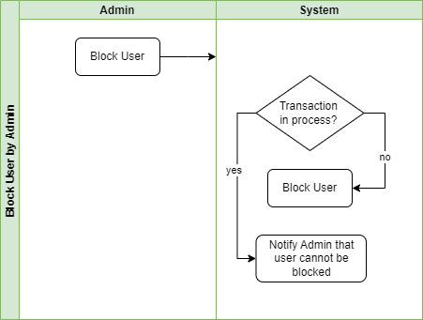

Figure - Block User

## **Use Case # 4 – Price Prediction Blog**

### **Description**

The following diagram illustrates the working of price prediction model for blog.

### **Flow Chart Diagram**

Figure - Price Prediction - Blog

## **Use Case # 5 – Price Prediction Daraz**

### **Description**

The following diagram illustrates the working of price prediction model for Daraz account.

### **Flow Chart Diagram**

Figure - Price Prediction - Daraz

## **Use Case # 6 – Logical Implementation**

### **Description**

The following diagram illustrates the working of logical implementation at the backend. RESTFUL APIs have been used at the backend to communicate with the frontend. A request (GET, POST, PUT, DELETE) with the user token is sent to server and appropriate response is returned to complete the request/response cycle. Additionally, same structure of response is followed for responses.

Figure - Data Response

Moreover, the logical flow is represented in the below flow chart with an example.

### **Flow Chart Diagram**

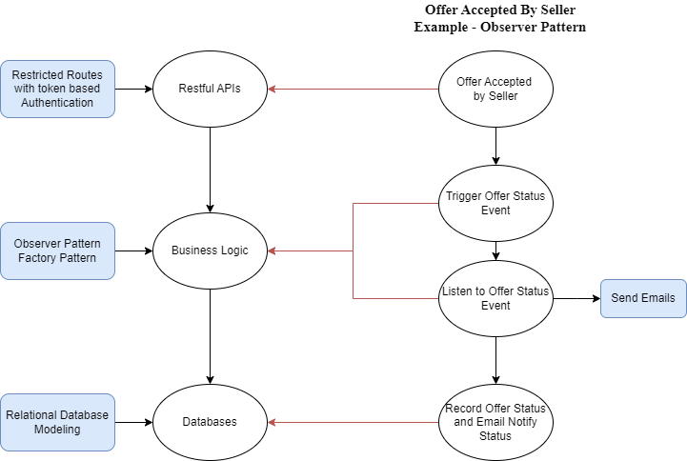

Figure - Logical Implementation

## **Use Case # 7 – Cron Jobs**

### **Description**

This scenario lists the Cron jobs that have been scheduled at the backend. A total of six jobs have been defined where a certain action is performed if a certain condition has been met in a given period of time. For instance, consider the job represented at point # 4, if the buyer does not transfer the payment to the system within the contract period, the contract will be cancelled, and the asset will be moved to a new status to accept any new offers.

### **Flow Chart Diagram**

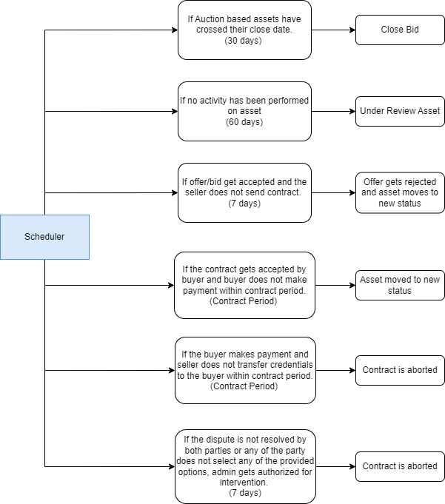

Figure - Cron Jobs